An LLM stands for Large Language Model, which is a type of artificial intelligence (AI) program that can understand and generate human language.

Large: The “large” in LLM refers to their size. These models are trained on massive datasets of text and code, which can amount to billions or even trillions of words. This large scale training allows them to learn complex relationships between words and sentences, leading to impressive abilities in understanding and generating language.

**How they work:**

* LLMs are based on deep learning techniques, particularly transformer models. These models analyze large amounts of text data to learn the statistical relationships between words.
* During training, the model adjusts its internal parameters to predict the next word in a sequence, given the preceding words. This process allows it to build an internal representation of language patterns.
* Once trained, the LLM can use its knowledge to generate new text, translate languages, answer questions, and perform other tasks that involve understanding and manipulating human language.

Some LLM Models

* **GPT**: Developed by OpenAI, known for its creative text generation capabilities.

GPT stands for **Generative Pre-Training**. First, it is a generative model, which can generate a new sample itself. For example, it can autocomplete a sentence or draw a new painting.

For 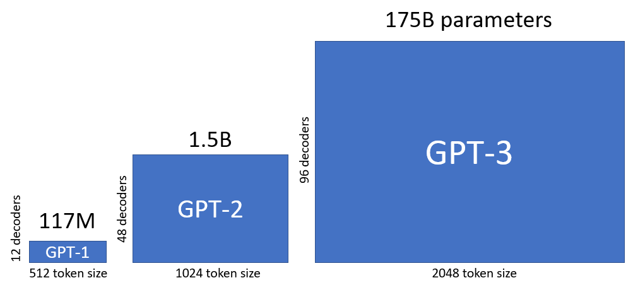

For GPT 4 it used 1.76 trillion parameters.

**Working principle**

LLM architecture refers to the internal structure and organization of a large language model (LLM). It’s a complex interplay of various components working together to understand and generate human language. Here’s a breakdown of some key elements:

**1. Transformer Model:**

This is the fundamental building block of most modern LLMs. Transformers rely on “attention mechanisms” to analyze relationships between words within a sequence, allowing them to understand context and long-range dependencies. It consists of several sub-layers:

* **Encoder**: Processes the input sequence and generates contextual representations for each word.
* **Decoder**: Uses the encoder outputs to generate the desired output sequence (e.g., translated text, answer to a question).
* **Attention layers**: These are the core of transformers, focusing on relevant parts of the input sequence at different times based on the current task.

**2. Pre-trained Embeddings:**

These are representations of words used as initial inputs to the transformer model. They capture semantic relationships between words learned from a massive dataset of text and code. Popular embedding libraries include Word2Vec and GloVe.

**3. Additional Components:**

* **Positional Encoding:**Since transformers lack inherent understanding of word order, this component encodes positional information into the model to preserve word sequence.
* **Layer Normalization:** Helps stabilize the training process and improves model performance.
* **Dropout:** A technique that randomly drops out some connections during training to prevent overfitting.

**4. Model Configurations:**

* **Number of Layers:**Increasing the number of layers allows the model to capture more complex relationships but increases computational cost.
* **Number of Attention Heads:** Each head focuses on different aspects of the input sequence, affecting the model’s ability to grasp different levels of meaning.
* **Hidden Layer Size:** Determines the dimensionality of internal representations, influencing the model’s memory and learning capacity.

**5. Training Process:**

* LLMs are trained on massive datasets of text and code using supervised learning techniques.
* During training, the model adjusts its internal parameters to minimize the difference between its predictions and the desired outputs (e.g., correct translations, accurate answers).

**6. Fine-tuning:**

A pre-trained LLM can be further adapted to specific tasks through fine-tuning on smaller datasets related to the desired domain (e.g., legal, medical).

**Terms to know**

Data Preparation:

* **Tokenization**: Breaking down text into individual units like words or characters.
* **Normalization**: Converting text to a consistent format (e.g., lowercase, removing punctuation).
* **Stemming and lemmatization:** Reducing words to their base form.
* **Stop words:**Common words like “the” or “is” that are often removed to improve processing efficiency.
* **Document embedding:** Transforming documents into numerical vectors for model interpretation.

**Model Selection and Training:**

* Transformer architecture: The dominant architecture for modern LLMs, focusing on “attention” mechanisms.
* Encoder-decoder architecture: Used for tasks like translation, where separate modules handle input and output processing.
* Generative pre-training: Training the model on general-purpose text data to create a versatile foundation.
* Supervised learning: Training the model using labeled data with known outputs (e.g., correct translations).
* Loss function: A metric used to evaluate the model’s performance and guide parameter updates during training.
* Backpropagation: An algorithm used to adjust model parameters based on the loss function.

**Fine-tuning:**

* Transfer learning: Utilizing the pre-trained LLM as a starting point for specific tasks.
* Domain adaptation: Adjusting the model to understand the specific terminology and context of a target domain.
* Few-shot learning: Fine-tuning with limited data for efficient adaptation.

**Application and Integration:**

* API integration: Allowing external applications to access the LLM’s capabilities.
* Dialogue management: Managing the flow of conversation in chatbot applications.
* Summarization and paraphrase generation: Condensing or rephrasing text for various purposes.
* Text generation: Creating different formats of text content like poems, code, scripts, etc.

Bonus terms:

* Hidden layer size: Controls the model’s complexity and capacity for learning.
* Batch size: Number of training examples processed in each model update.
* Dropout: Randomly dropping connections during training to prevent overfitting.
* Beam search: A technique for text generation that explores multiple possibilities simultaneously.
* Nucleus sampling: Filtering out unlikely words during generation for improved fluency.

**Hyper-parameter in LLM**

Hyperparameters in LLMs, like other machine learning models, act as the dials you can adjust to influence the model’s learning process and ultimately its behavior and performance. While they aren’t directly learned from the training data, setting them effectively is crucial for getting the best results from an LLM.

Here are some key points to understand about hyperparameters in LLMs:

What they do:

* Control the learning process: They influence how the model updates its internal parameters during training, impacting aspects like the pace of learning and the exploration of different solutions.
* Shape the model’s behavior: The settings affect the characteristics of the LLM’s outputs, such as randomness, creativity, accuracy, and conciseness.

how hyperparameters can affect different aspects of an LLM:

1. Learning process:

* Learning rate: Determines how quickly the model adjusts its internal parameters during training. A high rate can lead to fast but unstable learning, while a low rate may take longer to converge but result in more accurate outputs.
* Batch size: Specifies the number of training examples processed in each update. Larger batches can speed up training but require more memory, while smaller batches can lead to more stable training but take longer.
* Dropout: Randomly drops out some connections during training to prevent overfitting, where the model memorizes training data instead of learning generalizable patterns.

2. Model behavior:

* Temperature: Controls the randomness or creativity of generated text. A high temperature encourages exploration and surprising outputs, while a low temperature leads to more predictable and accurate responses.
* Beam width (during text generation): Determines how many potential next words the LLM considers at each step. A larger beam width explores more possibilities and can lead to diverse and interesting outputs, but it also increases computational cost and potential errors.
* Top-P Sampling: Filters out unlikely words during generation, reducing the chance of nonsensical text. Adjusting the probability threshold determines how strict the filtering is.

3. Specific task performance:

* Repetition penalty: Discourages the LLM from repeating the same words or phrases too often, promoting more varied and engaging text. This might be crucial for creative writing tasks.
* Hidden layer size: Controls the model’s complexity and capacity for learning. Adjusting it can impact accuracy on tasks like translation or question answering.

Finding the optimal settings:

* The ideal hyperparameter settings depend on several factors, including the specific LLM architecture, the desired task, and the training data.
* Experimentation and careful evaluation are essential for finding the best configuration for your use case.
* There’s no one-size-fits-all solution, and continuous monitoring and adjustments might be necessary as the model learns and the context changes.

Remember:

* Hyperparameters are powerful tools, but using them effectively requires understanding how they interact with the LLM and its training process.
* Consulting resources and exploring existing applications can provide valuable insights into effective hyperparameter settings for different goals.